**Costs of Production Worksheet**

1. **Define** Production.
2. **Describe** profit and profit maximization as two main goals of the firms.
3. **Explain** any two ways of increasing labour productivity.
4. **Define** Division of labour.
5. **Explain** any two advantages and two disadvantages of division of labour.

**Identify** Fixed Cost and Variable Cost from different pictures given below:

    

 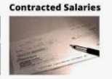



Solve the following worksheet:

